EXPERIMENT 15

Determination and plotting of Inductance (i) Self-inductance and Mutual inductance of current carrying coil, (ii) solenoid and toroid with different (a) length and (b) circumferential area.

Aim:
To determine and plot Inductance (i) Self-inductance and Mutual inductance of current carrying coil, (ii) solenoid and toroid with different (a) length and (b) circumferential area.
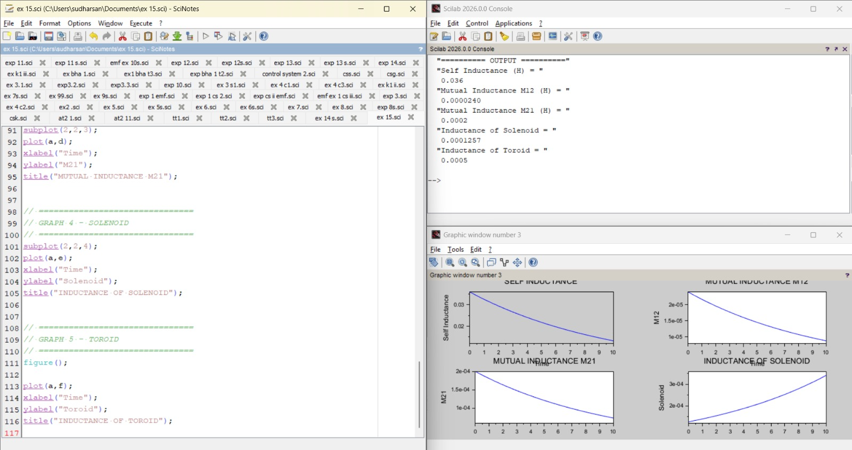
Software required: SCILAB version 6.0.1. Program:

Output:

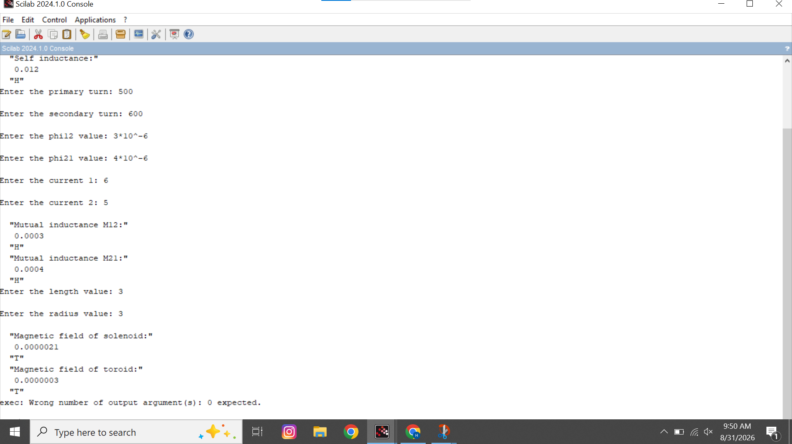

Theoretical calculations:
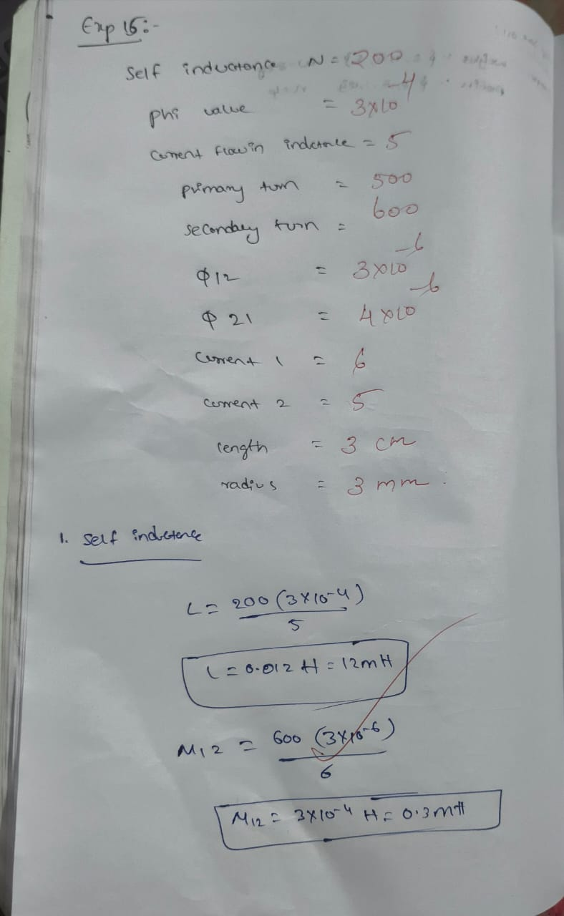

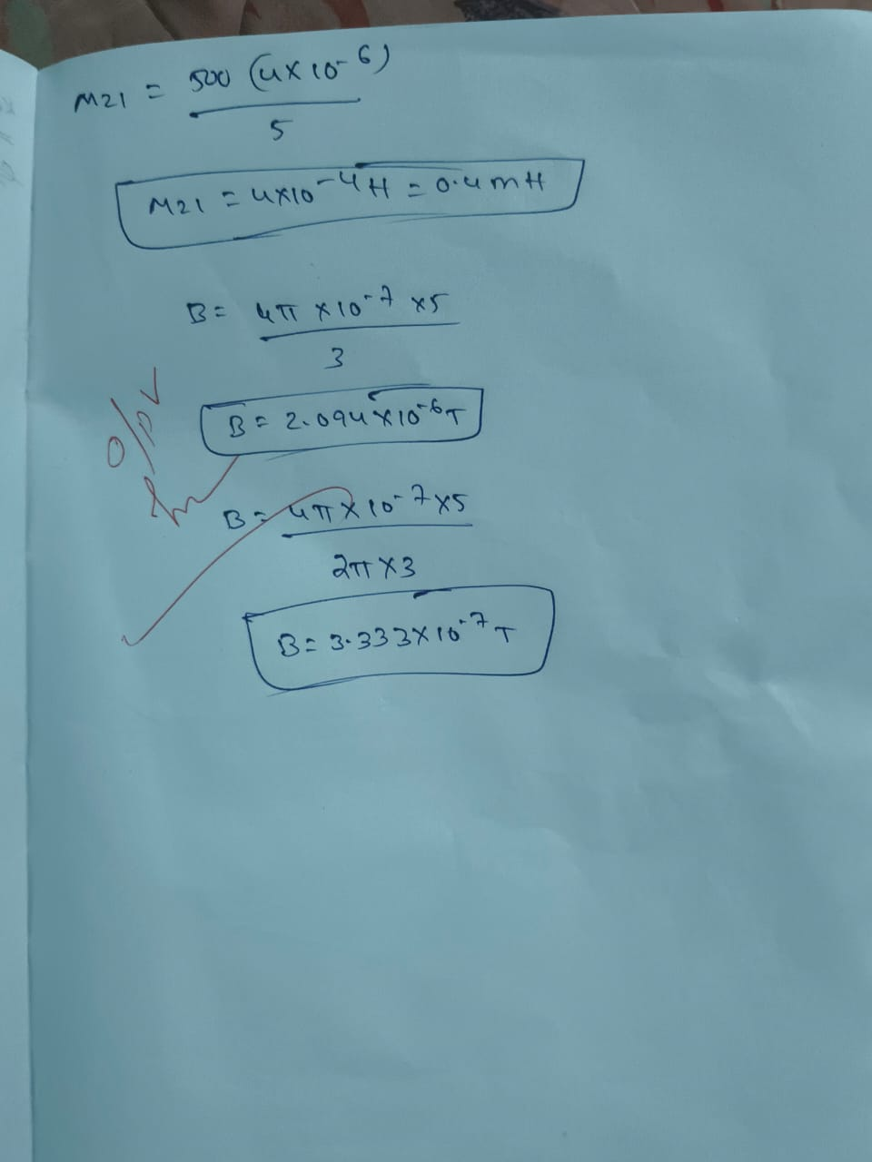

Result:
Thus determination and plotting of Inductance ,Self-inductance, Mutual inductance of current carrying coil, solenoid and toroid with different (a) length and (b) circumferential area are performed and verified successfully.

